# **JAVA FUNDAMENTALS SECTION 5:** Creating an Inventory Project

**Project 2**

**NAME: NAVULURI ANJALI**

**RG NO:192324137**

**Step 1: Open the Inventory Program**

Ensure you have the **Product** class and **Product Tester** class from Section 4.

**Step 2: Modify the Product Tester Class**

import java.util.Scanner;

public class ProductTester {

public static void main(String[] args) {

Scanner in = new Scanner(System.in);

// Variables to store user input

int tempNumber;

String tempName;

int tempQty;

double tempPrice;

// Input for the first product

System.out.print("Enter product number: ");

tempNumber = in.nextInt();

System.out.print("Enter product name: ");

in.nextLine(); // Consume newline

tempName = in.nextLine();

System.out.print("Enter product quantity: ");

tempQty = in.nextInt();

System.out.print("Enter product price: ");

tempPrice = in.nextDouble();

// Create first product

Product p1 = new Product(tempNumber, tempName, tempQty, tempPrice);

// Input for the second product

System.out.print("Enter product number: ");

tempNumber = in.nextInt();

System.out.print("Enter product name: ");

in.nextLine(); // Consume newline

tempName = in.nextLine();

System.out.print("Enter product quantity: ");

tempQty = in.nextInt();

System.out.print("Enter product price: ");

tempPrice = in.nextDouble();

// Create second product

Product p2 = new Product(tempNumber, tempName, tempQty, tempPrice);

// Display products

System.out.println(p1);

System.out.println(p2);

// Close the Scanner

in.close();

}

}

**Step 3: Modify the Product Class**

**Step 4: Add a Boolean Field active and Create Getter/Setter**

public class Product {

private int number;

private String name;

private int qty;

private double price;

private boolean active = true; // default value

// Constructor

public Product(int number, String name, int qty, double price) {

this.number = number;

this.name = name;

this.qty = qty;

this.price = price;

}

// Getter and setter for active

public boolean isActive() {

return active;

}

public void setActive(boolean active) {

this.active = active;

}

// Method to get the inventory value

public double getInventoryValue() {

return this.qty * this.price;

}

// toString method

@Override

public String toString() {

return "Item Number : " + number + "\n" +

"Name : " + name + "\n" +

"Quantity in stock: " + qty + "\n" +

"Price : " + price + "\n" +

"Stock Value : " + getInventoryValue() + "\n" +

"Product Status : " + (active ? "Active" : "Discontinued");

}

}

**Step 5: Use Ternary Operator in toString()**

This is already done in the **toString()** method in the step above.

**Step 6: Set active Value to False for p6**

Modify **ProductTester** to include creating and modifying **p6**.

public class ProductTester {

public static void main(String[] args) {

Scanner in = new Scanner(System.in);

// Variables to store user input

int tempNumber;

String tempName;

int tempQty;

double tempPrice;

// Input for the first product

System.out.print("Enter product number: ");

tempNumber = in.nextInt();

System.out.print("Enter product name: ");

in.nextLine(); // Consume newline

tempName = in.nextLine();

System.out.print("Enter product quantity: ");

tempQty = in.nextInt();

System.out.print("Enter product price: ");

tempPrice = in.nextDouble();

// Create first product

Product p1 = new Product(tempNumber, tempName, tempQty, tempPrice);

// Input for the second product

System.out.print("Enter product number: ");

tempNumber = in.nextInt();

System.out.print("Enter product name: ");

in.nextLine(); // Consume newline

tempName = in.nextLine();

System.out.print("Enter product quantity: ");

tempQty = in.nextInt();

System.out.print("Enter product price: ");

tempPrice = in.nextDouble();

// Create second product

Product p2 = new Product(tempNumber, tempName, tempQty, tempPrice);

// Create sixth product

Product p6 = new Product(tempNumber, tempName, tempQty, tempPrice);

p6.setActive(false); // Set active to false

// Display products

System.out.println(p1);

System.out.println(p2);

System.out.println(p6);

// Close the Scanner

in.close();

}

}

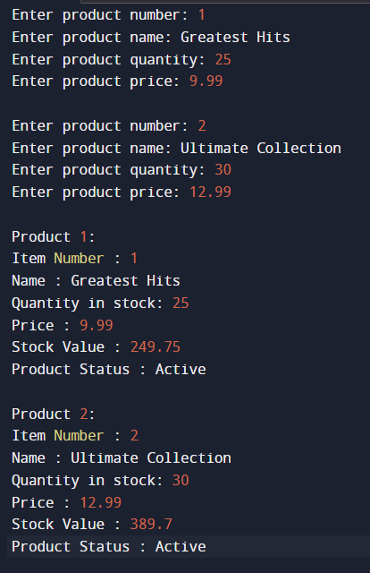

**Summary**

With these modifications, you should be able to run your program, input values for the **Product** objects, and see the correct output with active statuses displayed in a user-friendly manner. The **Product** class has also been enhanced to calculate and display the inventory value.